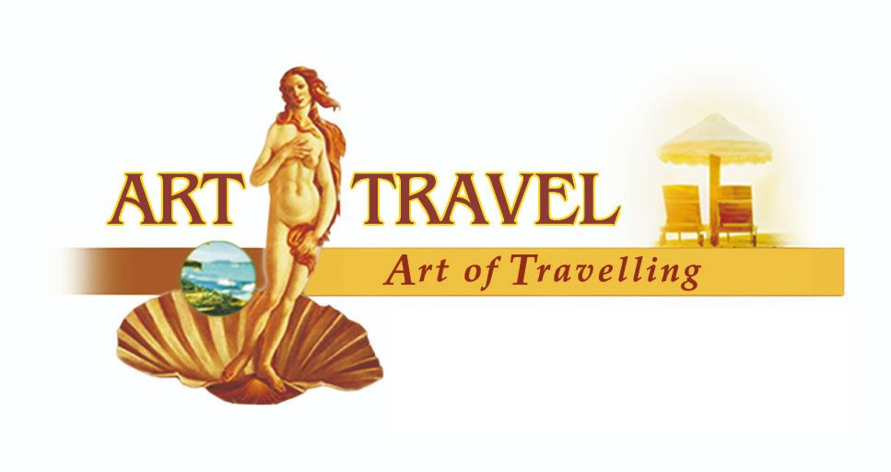 | Art of Travelling – Travels in Armenia & Georgia  booking@art-travel.am

ARMENIAN GOURMET TOUR
Guaranteed Group tour with arrival every Tuesday, 100% confirmation!
15.04.2024-31.10.2024
Duration: 5 nights / 6 days

TUESDAY
Arrival at Zvartnots International Airport. Transfer to the hotel.
Overnight in Yerevan.

WEDNESDAY
Breakfast at the hotel
During this group tour you will visit Amberd, a fortress founded in the 7th century. Then you will see Lake Kari, located at an altitude of 3250 meters on the slopes of Mount Aragats, the highest point of Armenia (4090 meters). Next will be a stop to familiarize with the production and taste Armenian dried fruits. Next follows a visit to Saghmosavank, a 13th century Armenian monastery, unique for its frescoes on biblical themes. Then you will have a stop at the Armenian Alphabet Monument, built in honor of the 1600th anniversary of the creation of the Armenian alphabet. This monument is unique not only in Armenia, but also in the whole world.
Departure: 09:00. Duration: 9-10 hours
The tour is conducted alternately in English and Russian languages.
One of the brightest examples of medieval Armenian architecture is the Amberd Fortress. When constructing it, Armenian builders used natural protection and erected the fortress on the mountain top surrounded by deep gorges.
Then we will visit the highest mountain in Armenia - Aragats (4090 meters). On the top of Mount Aragats there is a small and very cold Lake Kari (translated as "stone lake"). It is located at an altitude of 3250 meters, from where a wonderful panorama of the Ararat valley opens up.
Armenia has over 300 days of sunshine a year, making the country an ideal place for growing a variety of fruits. Visitors to the dried fruit factory will be treated to many flavor surprises with incredible combinations of fruits and vegetables.
Optional lunch at a local traditional restaurant at your own expense.
Next we will visit one of the richest and most famous spiritual centers of medieval Armenia - Saghmosavank Monastery (Monastery of Psalms), built in the 12th-13th centuries.
The Armenian Alphabet Monument was built to mark the 1600th anniversary of the creation of the Armenian alphabet and consists of 39 painted letters, among which you can find the letters of your name.
Overnight in Yerevan.

THURSDAY
Breakfast at the hotel
Within this group tour you will visit Tsakhkadzor, also known as the Valley of Flowers. In this popular ski and climate resort you will see the Kecharis monastery complex, take a cable car ride and enjoy the beauty of the area. Next you will have a stopover near Lake Sevan, the pearl of Armenia. Sevanavank Monastery , located on a peninsula, is the point from where you can see the whole beauty of Lake Sevan.
Departure: 10:00 Duration: 7-8 hours
The tour is conducted alternately in English and Russian languages.
Tsaghkadzor is a modern ski resort in Armenia, located 60 km from Yerevan, at an altitude of 1845 meters above sea level. It is one of the most popular and hospitable resorts in Armenia. From the high-speed cable car you can enjoy marvelous scenery, and when the weather is clear, you can enjoy a breathtaking view of Mount Ararat. In the northwestern part of Tsaghkadzor is the Kecharis Monastery, built in the 11th-13th centuries.
Lake Sevan, the "blue pearl" of Armenia, is the largest lake in the Caucasus and one of the largest mountain freshwater lakes in the world. Its area is 1400 square kilometers and it is located at an altitude of 1900 meters above sea level.
Optional lunch in a local traditional restaurant at your own expense.
At the end of the tour we will visit the medieval Sevanavank Monastery, which offers a beautiful view of Lake Sevan. At the end of the tour you can taste a shashlik from unique Sevan trout!
Overnight in Yerevan.

FRIDAY
Breakfast at the hotel
Within this group tour you can enjoy the Armenia's most amazing sights! You visit the Khor Virap Monastery, a perfect place to admire the most picturesque views of the sacred Mount Ararat, then you see Noravank Monastery, have a wine tasting at the "Hin Areni" winery in the village of Areni, one of the oldest settlements in Armenia, famous for its wines. Finally, you visit the ancient "Cave of Birds", also called Areni-1.
Departure: 10:00. Duration: 9-10 hours
The tour is conducted alternately in English and Russian languages.
Our first stop is Khor Virap Monastery, one of the holy places of the Armenian Apostolic Church. According to legend, this is the place where Gregory the Illuminator was imprisoned for preaching Christianity. Nowadays Khor Virap is the closest place to Mount Ararat in Armenia. It offers a magnificent view of the legendary mountain.
Then we move to the "The Cave of Birds" consisting of 3 halls and having an area of 500 m², most of which is still unexplored. The world's oldest (over 5500 years old) leather shoes, a woman's skirt attributed to 3900 BC and the world's oldest winery were found in the cave.
The village of Areni has been the cradle of Armenian winemaking for thousands of years. The “Hin Areni winery” masterfully showcases historical and local varieties of Armenian grapes.
Optional lunch at a local traditional restaurant at your own expense.
Noravank Monastery was one of the significant cultural and religious centers of medieval Armenia, surrounded by rugged cliffs and consisting of unique churches from the 13th - 14th centuries.
Overnight in Yerevan

SATURDAY
Breakfast at the hotel
Within this group tour, you will explore Armenia's most unique sights! First you will visit Garni, the only pagan temple in Armenia. The next stop is the Geghard Monastery, partially carved out of the rocks. At the end of the tour you will have the opportunity to watch the process of baking lavash (Armenian thin bread), which is one of the most beautiful and widespread Armenian national traditions.
Departure: 10:00. Duration: 5-6 hours
The tour is conducted alternately in English and Russian languages.
You will see the Charents Arch, created by architect Rafael Israelyan. One day on his way to Garni he stopped at this place and noticed a beautiful view of Ararat from there. It moved him to the decision to build an arch as a kind of a "temple" to Ararat.
The pagan temple of Garni is the only monument of the Hellenistic era that has survived in Armenia. This marvelous temple, dedicated to the Sun God Mitra, was built in the 1st century AD.
The famous Geghard Monastery with rock-cut churches was built in the 12th-13th centuries. At first it was called Ayrivank ("cave monastery"), and then it was renamed Geghardavank, meaning "the Monastery of the Spear", originating from the spear which had wounded Jesus at the Crucifixion, allegedly brought to Armenia by one of apostles and being kept at the monastery for a long time. The monastery is included in the UNESCO World Cultural Heritage List.
Lavash is one of the most popular culinary highlights of Armenia and is an integral part of Armenian cuisine. During a master class you will learn the old tradition of lavash baking and, of course, taste it with fresh herbs and delicious local cheese.
After return to Yerevan, you will have free time for a lunch and then a walking sightseeing tour in the center of the city. You will learn the thousand-year history of the Armenian capital along with a tour of architectural monuments such as the Opera House, Cascade Complex, National Assembly Building and Republic Square as well as the central streets of the city. From the height of the observation deck you will see the whole city. Walking around Yerevan is the best way to truly immerse yourself in the culture, history and local cuisine.
Overnight in Yerevan

SUNDAY
Breakfast at the hotel
Transfer to Zvartnots International Airport.

Program is subject to change due to organizational reasons without reducing the scope of services provided!

The price includes | The price doesn’t include
- Transfers airport – hotel / hotel - airport;  - BB Accommodation for 4 nights in Yerevan in standard DBL rooms;  - Professional tour guide: ENG + RUS alternately;  - Air-conditioned vehicles;  - Bottled water and buns;  - Entrance tickets according to the program;  - WiFi in vehicles on tour;  - Vehicle and passenger insurance;  - Wine tasting;  - Master class in lavash baking and tasting. | o Airline tickets;  o Health Insurance;  o Drinks and gratuities;  o Lunches (optional lunches on tour approx. 3 500 AMD – 4 500 AMD. Only cash payment)  o Dinners;  o Any services not mentioned in the section “The price includes”

